Price: 500.000€ (or near offer) 84359 Simbach
Price/m²: 1,95 €/m²
living space about 300,00 m²
plot area: about 56.000,00 m²
rooms: 17
Built: 1504
Last moving in: 1994

Amenities:

- under monumental protection (only external façade)
- winter garden(conservatory)
- balcony
- tile floor- floorboards
- fitted kitchen ,pantry
- bathroom/Toilet separate, bathroom with window and one with bathtub
- roof fully developed, granny-flat
- carport, garage
- renovated
- masonry heater
- wood, oil heating

Object description

Idyllic 2-storied farmhouse with a marvelous romantic view into the inntal (river valley)
Well water, 2 balconies, terrace , Inner courtyard
Huge fruit and vegetable-garden (120 m²) with greenhouse
Outbuildings: plant floor, earth cellar, garage, repair and assembling shop, lumberyard, horse stable with tack room, cowshed and diary,

Position paper
5,6 ha ground surrounding the farm with an own driveway.
Two great meadows with two horsetroughs
Small pond
7 minutes away from Simbach
120 minutes away from Munich
120 minutes away from Salzburg

Floor plan:

Ground floor, kitchen living, bathroom, separate toilet, pantry, adjoining room,
heating room, living room with masonry heater,
first floor: 6 Rooms and 1 bathroom,
Attic: granny flat with fitted kitchen, little pantry, bathroom, open
living-and-eating-area , Swedish stove
Notation:

Central heating (oil), and stove, air shaft till the attic,
Sewage plant must be upgraded (around 8.000€)

Fruits:
More than 18 different fruit sorts and bushes.
Contact:
E-mail: tobias-t@t-online.de
phone: +49 8571 9229994

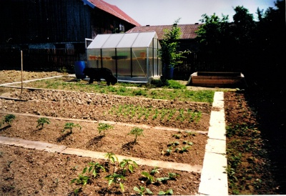
pictures:
